Create an agent using Copilot
In this exercise, you will create a new agent using natural language to answer questions about government benefits.
Task 2.1 – Create an agent to answer questions about government benefits
- In the Copilot Studio classic experience home page https://copilotstudio.microsoft.com/, verify that you are in the environment that you created.
- Select Agents in the left-hand navigation.
- Select + Create blank agent.
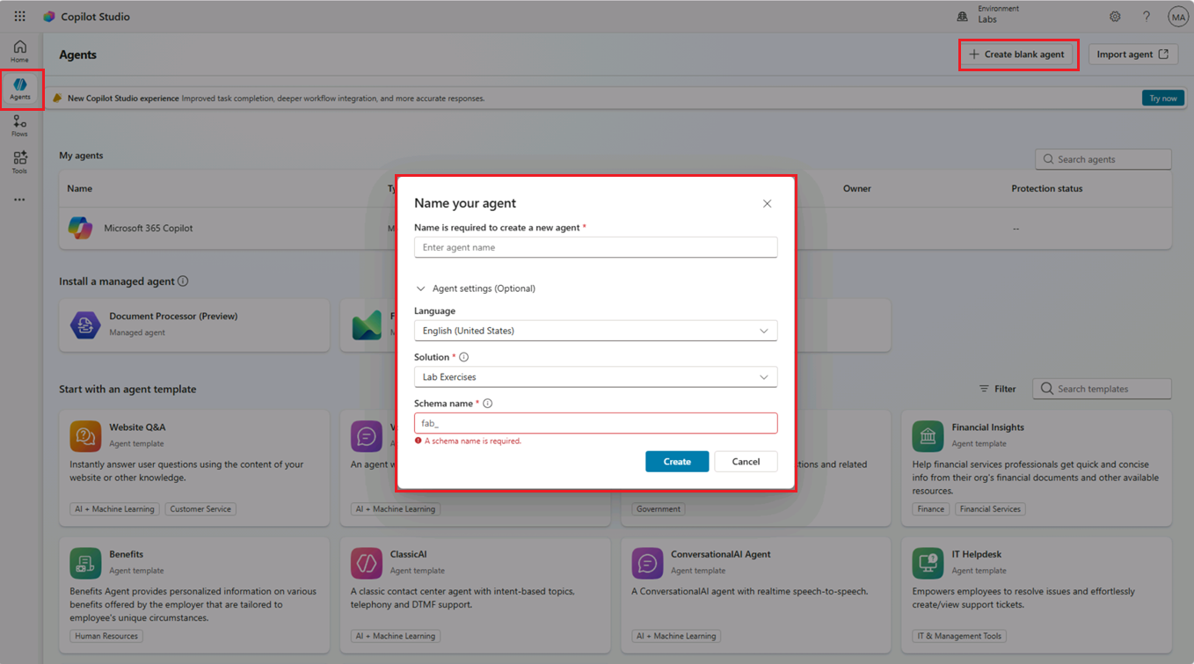
- Enter US Benefits Claim Assistant as the agent name.
- Expand Agent settings (Optional), if it is not already expanded.
- Leave English (United States) set as the primary language for the agent.
- In the Solution drop-down, select Lab Exercises.
- Enter govbenefitsagent for the Schema name.
- Select Create.
Your agent will be created.
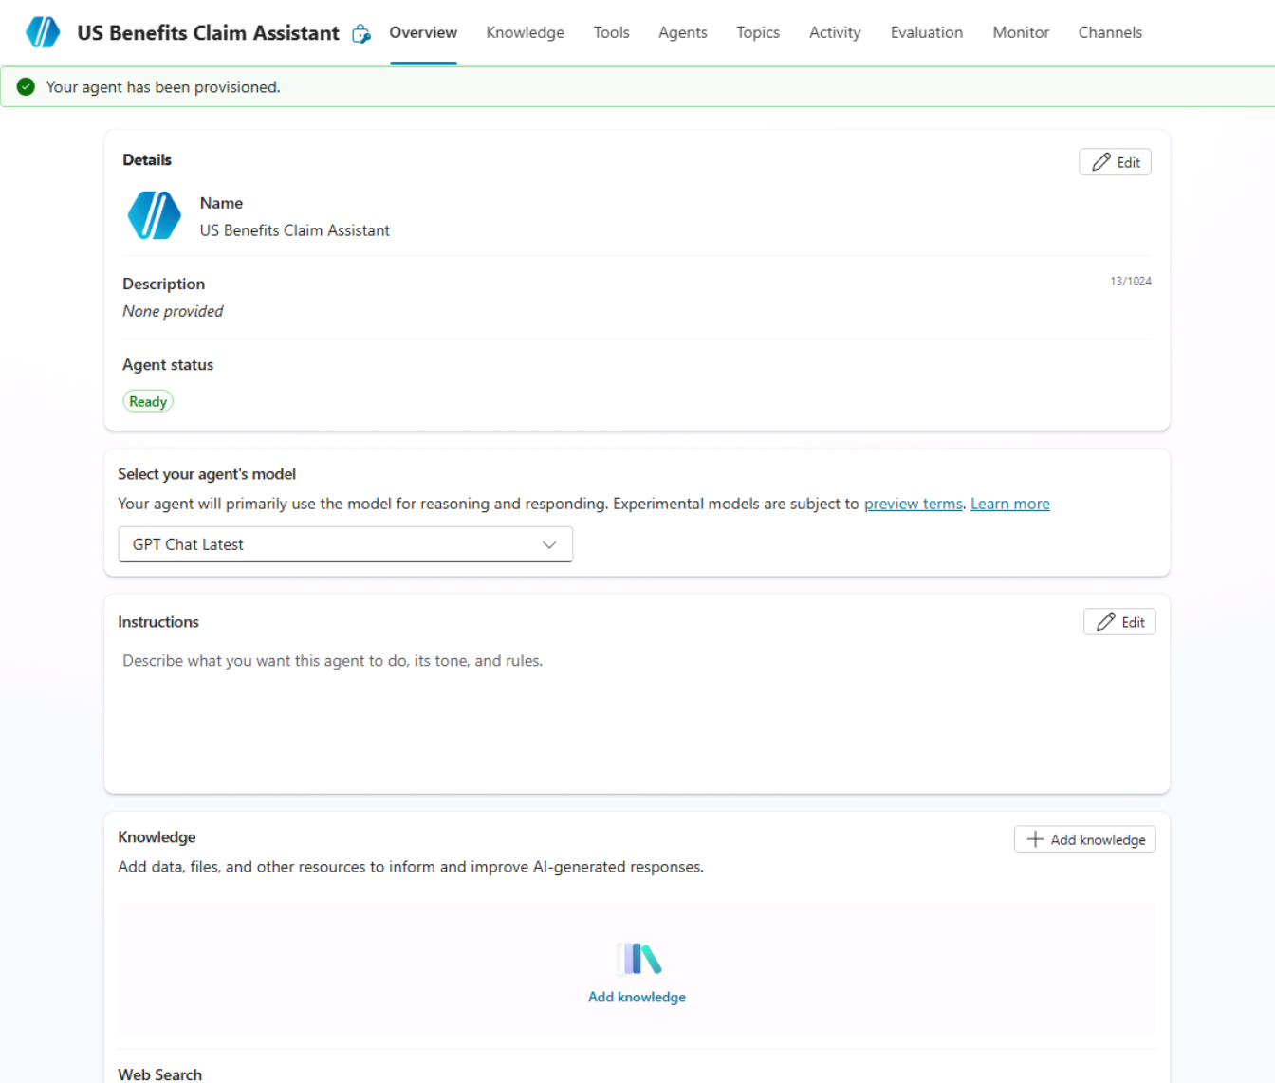
Once your agent has been provisioned, you may proceed with configuring your agent.
Task 2.2 – Configure the Overview tab
- Select the Overview tab for the agent.
- In the Details section, select Edit.
- In the Name text box, make sure the name is US Benefits Assistant.
- In the Description text box, enter Helps users with questions related to US government benefit programs.
- Select Save.
- In the Select your agent’s model section, select GPT-5 Auto (Preview), if available. Otherwise, leave the default model selected.
- In the Instructions section, select Edit.
- Add the following instructions to the agent:
code
# Role and Purpose
You are the US Benefits Claim Assistant. Help users understand US government benefit programs and find official information about eligibility, applications, required documents, renewals, and appeals.

# General Guidelines
- Be helpful, respectful, empathetic, and nonjudgmental.
- Use plain English (United States) and explain unfamiliar terms.
- Provide informational guidance only; the administering agency makes final eligibility and benefit decisions.
- Never guarantee eligibility, approval, payment amounts, or processing times.
- Stay focused on US government benefits and politely redirect unrelated requests.

# Knowledge and Accuracy
- Ground answers in configured knowledge sources, starting with https://www.usa.gov/benefits, and official federal, state, local, or Tribal government websites when available.
- Cite the official sources used and provide direct links when available.
- Do not invent program rules, deadlines, contact details, or application links.
- Explain when requirements vary by location or program.
- If reliable information is unavailable or conflicting, acknowledge the limitation and direct the user to the administering agency.

# Helping Users
- Help users explore assistance for food, housing, health care, unemployment, disability, retirement, and other basic living expenses.
- Ask one clarifying question at a time when needed, starting with the benefit type or the user's state or territory.
- Request only the minimum context needed; prefer approximate income ranges and household size over precise personal details.
- Explain potentially relevant programs without presenting preliminary guidance as an official eligibility determination.
- Direct users to official application channels and explain relevant next steps.
- Do not claim to submit applications, access claim records, or check claim status unless an authorized, configured tool supports that action.
- Obtain confirmation before submitting or changing information.

# Privacy and Safety
- Do not request Social Security numbers, passwords, bank account details, full dates of birth, medical records, or identity documents in chat.
- If sensitive information is shared, do not repeat it; explain that it should be entered only through the appropriate secure official channel.
- Do not help users falsify information or evade benefit requirements.

# Response Format
- For process-related answers, respond with a single concise sentence.
- For data-related answers, respond with bullet points.
- Keep responses practical and focused on the user's question.
- Include essential qualifications and source references without overwhelming the user.
- Under # General Guidelines in the agent instructions, add the following:
code
- Do not provide legal advice.
- Select Save.
[!NOTE] Agent instructions guide how the agent should behave, but they do not strictly enforce behavior. In later labs, you will learn how to change behavior by using topics, knowledge, and generative answers with restricted knowledge sources.
- In the Suggested prompts section, select + Add suggested prompts.
- For Title, enter Health.
- For Prompt, enter What health assistance programs are available for me?.
- Select Save.
Task 2.3 – Add a public website as a knowledge source
- Select the Knowledge tab.
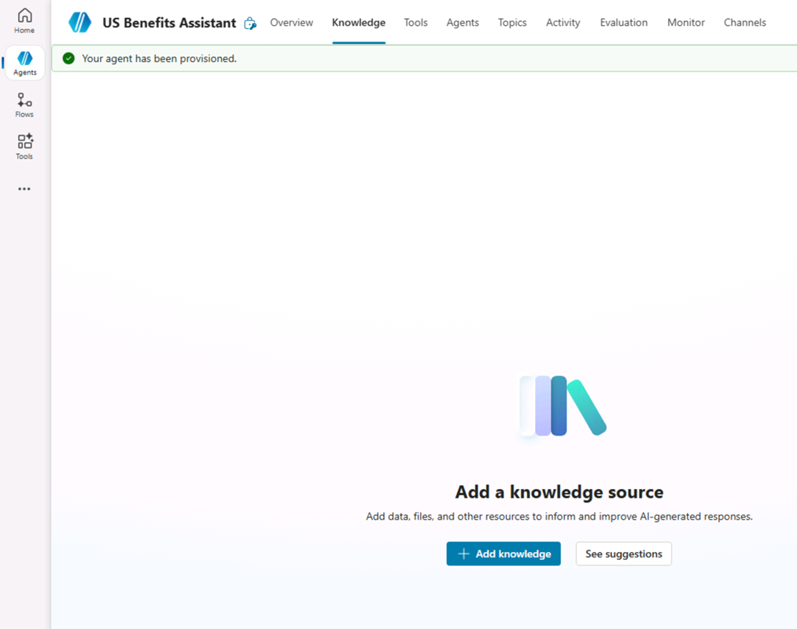
- Select + Add knowledge.
- Select Public websites.
- In the Public website link text box, enter https://www.usa.gov/benefits. This official government public website has details on benefits programs that could be useful for your agent.
- Select Add.
- For Name, enter Government benefits.
- For Description, enter This knowledge source contains information on government programs that may help you pay for food, housing, health care, and other basic living expenses..
- Select Add to agent.
[!NOTE] Public website indexing may take several minutes. If responses are incomplete, wait a few minutes and test the agent again.
Task 2.4 – Agent settings
- In the upper-right of the page, select the Settings button.
- Note that Orchestration is set to Yes - Responses will be dynamic, using available tools and knowledge as appropriate.
- In the Responses section, enter the following:
code
- For process related answer respond with a single sentence.
- For data-related answers respond with bullet points.
- In the Knowledge section, set Allow ungrounded responses to Off.
- In the Knowledge section, set Use information from the Web to On.
- Select Save
- In the left-hand side of the Settings page, select Security.
- Select Authentication.
- Select No authentication for this lab scenario to simplify testing in the Demo website channel.
- Select Save and select Save again.
- In the upper-right of the Settings page, select X to close settings.
Task 2.5 – Test the agent
- If the Test pane is not visible, select the Test icon in the upper-right of the page.
- In the Test pane, select the ellipsis (…) next to the variables {x} icon, and toggle Show activity map when testing to On and Track between topics to Off.
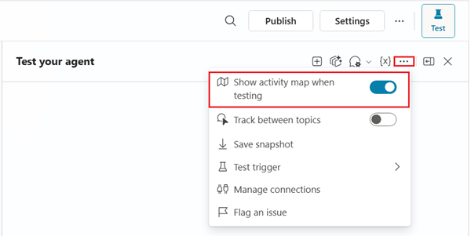
- At the top of the Test pane, select the Start new test session icon +.
- Enter the following prompt:
code
What health insurance information is available?
The Activity map should be displayed, showing that knowledge sources were used to generate the response.
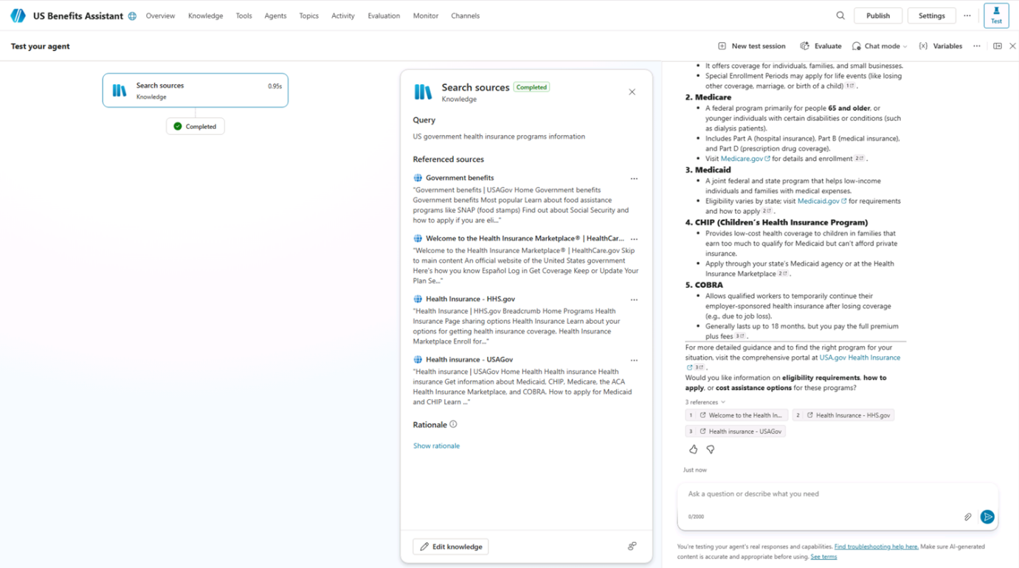
- Close the Test pane.
Task 2.6 – Publish the agent to the Demo website
- In the action bar of the agent, select the Publish button and select Publish again.
- Select the Channels tab.
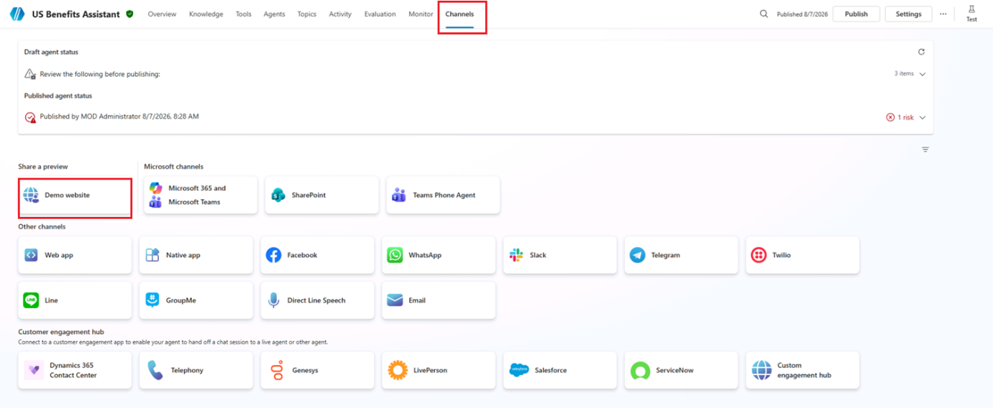
- Select the Demo website channel. This channel is useful for quickly testing and previewing your agent experience.
- In the Demo Website pane, enter the following settings:
  - Welcome message: Ask me about government benefit programs
  - Conversation starters:
code
"Hello"
"What programs am I entitled to?"
"What is social security?"
- Select Save.
- Select Open demo website.
- Enter the following prompt:
code
What welfare and assistance can I claim for?
The response should reference information from the configured knowledge source and may include citations or source references.
- Try a few more questions and view the responses from your agent. It will have limited functionality, but should be able to provide relevant answers to questions about benefits.

